# Supplemental Information Requirements for Class VI Project Reviews by TCEQ UIC Permits Section

In addition to the information requested in the Class VI permit application, supplemental information is required for the Texas Commission on Environmental Quality (TCEQ) Underground Injection Control (UIC) Permits Section staff to make a determination that drilling and operating an anthropogenic CO2 injection well for geologic storage or constructing or operating a geologic storage facility will not impact or interfere with any previous or existing Class I injection well, including any associated waste plume, or any other injection well authorized or permitted by the commission. This information provides additional key criteria necessary for reviewing Class VI applications, with a focus on modeling and simulation assessments. It emphasizes the importance of validating the quality of 3D models and ensuring their alignment with actual data. Other crucial considerations include identifying all sources of possible pressure buildup and plume interactions within the injection reservoir including other proposed Class VI projects and Class I and Class II injection wells and addressing these sources in the site characterization and the associated confinement and containment model and the derived Area of Review (AOR). Additional considerations include conducting sensitivity analyses and defining workflows for uncertainty and optimization using Monte Carlo simulations. By addressing these factors, the TCEQ UIC Permits Section staff can gain a deeper understanding of reservoirs and make more informed decisions to ensure Class VI projects do not adversely affect Class I wells. This comprehensive approach is designed to support project success and regulatory compliance.

1. **Well Correlation:** Provide a detailed well correlation analysis, including the following:

* **Formation Tops and Marker Beds:** Clearly identify and label formation tops, marker beds, and other key geological features used for correlating between wells. Ensure that all relevant stratigraphic and structural details are included to support accurate well-to-well comparisons.
* **Lateral Continuity:** Provide an explanation of lateral continuity between wells, particularly in complex or heterogeneous reservoirs. Highlight any challenges encountered and describe how they were addressed to ensure accurate correlations.
* **Uncertainty Handling:** Describe how uncertainties in well correlations were identified and mitigated in the model. Include any methods used to address variations in data quality, such as integrating seismic data, regional geology including the sources of this information, and/or using statistical approaches. Additionally, provide a comparison of the different methods employed to assess uncertainty and justify the chosen approach.
* **Validation:** Include a section on how the well correlations were validated, outlining any cross-validation with other datasets or methods to confirm the reliability of the correlations.

1. **3D Model Cell Size Validation:** Provide a comprehensive validation of cell size in the 3D model particularly in the Area of Review, including the following:

* **Average Well Spacing:** Report the average spacing between wells in the model.
* **Minimal Vertical Thickness of Lithological Units:** Specify the minimum vertical thickness of lithological units considered in the model.
* **Graphical Representation:** Include graphs that illustrate reservoir thickness at various wells based on well log data, showing both the pre- and post-“upscaling” conditions. Ensure the graphs are clearly labeled and provide necessary legends for easy interpretation *(refer to Figure 1 on page 7 as an example)*.
* **Upscaling Methodology:** Describe the methodology used for upscaling the data, including any assumptions made and their implications on model accuracy.
* **Sensitivity Analysis:** If applicable, include a sensitivity analysis demonstrating how variations in cell size affect the model's predictions. This analysis can provide insights into the robustness of the cell size selection.

1. **Boundary Conditions and Grid Orientation:** Provide details on how boundary conditions and grid orientation were applied in the reservoir simulation model.

* **Boundary Conditions:** These define how fluids and pressures interact at the simulation area’s edges. Accurate boundary settings reflect real-world conditions (e.g., no-flow or constant pressure), ensuring reliable reservoir performance predictions. Incorrect settings can lead to unrealistic results and misinterpretation of flow dynamics.
* **Grid Orientation and Stress Distribution:** Aligning the grid with geological features (faults, stress directions, depositional systems) is critical for accurate flow simulation and permeability distribution. Proper alignment with the regional stress field ensures accurate mechanical behavior predictions during operations like drilling or CO2 injection. Supporting data for grid orientation enhances model accuracy and reliability.

1. **Well Logs Calibration:** Provide graphs illustrating the calibration of neutron/density logs versus porosity data from core laboratory tests.

* **Calibration Process:** Explain the calibration process in detail, including the methodology used to align the logs with core porosity measurements, ensuring accurate porosity estimation. Discuss how model values align with core data, addressing any discrepancies and how they were resolved.
* **Graphical Representation:** Ensure the graphs clearly depict the relationship between the calibrated logs and core porosity data, highlighting any significant trends or deviations. Include legends and labels for clarity *(refer to Figure 2 on page 8 as an example)*.
* **Validation of Calibration:** Describe any validation steps taken to confirm the accuracy of the calibration process, such as cross-referencing additional data or statistical analysis.

1. **Porosity and Permeability Validation:** Provide a chart from the 3D model illustrating the correlation between porosity and permeability cubes, along with a comparison to raw core data.

* **Correlation Analysis:** Highlight trends or deviations in the porosity-permeability relationship, supported by statistical measures like correlation coefficients.
* **Validation Techniques:** Describe the techniques used to validate the porosity and permeability distributions, such as cross-validation with additional well data, sensitivity analyses, or comparisons with industry benchmarks.

1. **Upscaling Validation:** Provide histograms comparing porosity logs (neutron/density) versus the upscaled cells in the 3D model *(refer to Figure 3 on page 9 as an example).* Repeat this for each upscaled parameter, including lithology or facies/flow units. If the differences exceed 5%, provide an explanation *(refer to Figure 4 on page 9 as an example).*
2. **Properties Distribution and Trend Maps:** Provide 2D trend maps and 3D cubes illustrating the distribution of properties, if applicable.

* **Interpolation Method:** Describe the method used for interpolating lithologic units, flow units, and facies within the 3D subsurface model. Explain how the chosen method enhances the accuracy of the property distribution. Provide an interpretation of the trend maps and 3D cubes, highlighting significant patterns and anomalies in property distribution that may influence reservoir behavior.
* **Geostatistical Analysis:** Include a comprehensive geostatistical analysis, detailing the types of semivariograms used and the interpolation methods applied, such as kriging, co-kriging, or stochastic simulation. Provide a rationale for the chosen approach, highlighting how it aligns with the geological characteristics of the reservoir.
* **Variogram Parameters:** Include key variogram parameters for each distributed 3D property, such as lithology/facies/flow units, and porosity. This should encompass major, minor, and vertical ranges, as well as nugget and sill values. Ensure that these parameters are clearly defined and their significance explained.
* **Validation of Distribution Models:** Discuss any validation techniques employed to assess the reliability of the property distribution models. This may include comparison with well data or cross-validation methods to ensure the robustness of the interpolated results *(refer to Figure 5 on page 10* *as an example)*.

1. **Cut-off Estimation:** Provide the cut-off values utilized to differentiate between reservoir and non-reservoir zones, along with the methodology employed for this classification.

* **Cut-off Values:** Clearly specify the cut-off values for key properties that were used to define reservoir and non-reservoir zones. Include any variations in these values based on geological or operational factors *(refer to Figure 6 on page 10 as an example)*.
* **Methodology:** Describe the methodology used to establish these cut-off values. This may include statistical analyses, data-driven approaches, or empirical relationships derived from core and log data.

1. **Gross and Net Thickness Maps:** Provide gross and net thickness maps, utilizing the Net-to-Gross (NTG) parameter to validate reservoir thickness in the injection area (Area of Review, AOR).

* **Map Presentation:** Ensure that the maps are clearly labeled and visually distinguishable, illustrating both gross and net thickness across the AOR. Include a legend to aid interpretation.
* **Net-to-Gross (NTG) Calculation:** Describe the methodology used to calculate the NTG parameter, including the criteria for determining net reservoir thickness versus gross thickness.
* **Correlation with Reservoir Characteristics:** Discuss how the gross and net thickness maps correlate with other reservoir characteristics, such as porosity and permeability. Highlight any significant trends observed in the data.
* **Validation of Thickness Estimates:** Include information on the validation of thickness estimates, such as comparisons with well log data, core measurements, or historical production data. Describe any techniques employed to ensure the reliability of the thickness assessments.

1. **Sensitivity Analysis and Tornado Chart:** Provide the results of the sensitivity analysis along with the corresponding tornado chart for key parameters influencing the CO2 injection project.

* **Sensitivity Analysis Overview:** Include a brief description of the sensitivity analysis methodology used to assess how variations in key parameters impact the model's outcomes. Specify the parameters analyzed, such as porosity, permeability, injection rate, and reservoir pressure.
* **Results Presentation:** Present the results of the sensitivity analysis in a clear and concise manner, highlighting which parameters exhibited the most significant effects on the model outputs. Include statistical metrics, if applicable, to quantify the sensitivity of each parameter.
* **Tornado Chart:** Provide a tornado chart that visually represents the sensitivity analysis results. Ensure the chart is clearly labeled, showing the relative impact of each parameter on the model outcomes. The chart should facilitate quick comparisons and highlight the most critical factors affecting CO2 behavior and storage capacity.
* **Interpretation of Results:** Offer an interpretation of the sensitivity analysis findings. Discuss how the input variables with the greatest influence on the model outcomes could potentially affect the pressure front and CO2 plume radius.
* **Recommendations:** Based on the sensitivity analysis, provide recommendations on how to improve model accuracy and reliability of the model.

1. **Uncertainty & Optimization Workflow:** Describe the workflow utilized for uncertainty analysis and optimization within the model.

* **Workflow Overview:** Provide a detailed summary of the steps taken during the uncertainty analysis and optimization process, emphasizing the key methodologies and tools used. Describe how uncertainties in input parameters were identified, quantified, and integrated into the modeling framework. If relevant, include an uncertainty analysis for transmissivity, vertical fault extensions (particularly those within the AOR), and lithological variations in the confining and injection zones, especially if the regional extent of the primary seal or reservoir raises concerns (e.g., potential fluvial erosion or shelf-edge progradation).
* **Monte Carlo Simulation:** Include a Monte Carlo simulation chart that illustrates the distribution of outcomes based on the uncertainty analysis including plume and pressure front size. Present the results for the P10, P50, and P90 probability models, clearly labeling each probability level to facilitate understanding of the range of possible scenarios.
* **Results Presentation:** Summarize the results of the Monte Carlo simulation, highlighting the implications of the P10, P50, and P90 outcomes for decision-making. Discuss how these probabilities relate to the confidence levels associated with various project scenarios.
* **Interpretation of Results:** Offer an interpretation of the uncertainty analysis findings. Discuss how these uncertainties could potentially affect the pressure front and CO2 plume radius.
* **Optimization Insights:** Describe any optimization techniques employed as part of the workflow and their impact on model performance.

1. **Current Formation Pressure Data: Include up-to-date formation pressure data to ensure accurate modeling of the pressure front and CO2 plume radius.**

* **Additional Parameters: Include any additional relevant parameters that could influence the pressure front and CO2 plume behavior or assist in demonstrating that Class VI wells do not affect the size or geometry of the pressure front or plume of existing Class I wells.**
* **Actual Data Used in Models: Submit the raw data inputs utilized in the modeling process for transparency and verification.**

1. **History Matching Results: Include history matching results to validate the model’s accuracy and confirm alignment with real-world conditions.**
2. **Results Presentation:** Provide the formation pressure map exhibiting the maximum extent of predicted increase in pressure due to CO2 injection beyond the AOR boundary at the end of the injection period, along with the plume distribution map, clearly marking the **AOR boundaries.**
3. **Parameter Ranges for Model Computations:** Provide the range of the following parameters, including min, max and average, utilized within the Area of Review (AOR):

* Initial formation pressure, psi
* Temperature, F
* Net thickness, ft
* Salinity, mg/L
* Porosity, %
* Permeability, mD
* Rock Compressibility, 1/psi
* Project Area, mi²
* Reservoir Area, mi²
* Injection Well Radius, ft
* Injection duration period, year
* Critical pressure increase (AOR calculation), psi: including 𝑝𝑢 - initial fluid pressure in the USDW (psi), 𝜌𝑖 - injection zone fluid density (lb/gal), 𝑧𝑢 - representative elevation of the lowermost USDW (ft), 𝑧𝑖 - representative elevation of the injection zone (ft)
* Water Corey Exponent (m)
* Gas Corey Exponent (n)
* Endpoint Water Relative Permeability (kra0)
* Endpoint Gas Relative Permeability (krg0)
* Residual Water Saturation (Sar)
* Critical Gas Saturation (Sgc)

Below is the link to EASiTool, which TCEQ currently uses for pressure front and sensitivity analysis estimation and validation:

<https://easitool5-pe1pac0l4h.streamlit.app/>

Username: NonGCCCsponsor

Password: TemporaryP@88

Any technical questions can be discussed with Seyyed A. Hosseini, Ph.D., Research Professor, Bureau of Economic Geology, University of Texas at Austin at [seyyed.hosseini@beg.utexas.edu](mailto:seyyed.hosseini@beg.utexas.edu).

1. **Other Proposed Class VI Projects and Class I and II injection Wells: Identify other subsurface injection operations that are proposed, are currently permitted to operate, or have previously operated within the extended area beyond the AOR that is affected by increased reservoir pressures due to CO2 injection. Provide a list of injection wells including well type, operator name, location, distance from the proposed Class VI injection wells, operational status, well depth, injection reservoir formation, and injection reservoir depths. Describe whether any Class VI projects or Class I or II wells are proposed, are injecting, or have previously injected into the same injection reservoir as the proposed Class VI injection wells. Provide the maximum proposed and permitted injection rates and discuss whether there is potential for pressure interference between the injection wells or mingling of the plumes. The pressure effect of the other proposed and permitted injection wells injecting into the same injection reservoir should be modeled at maximum proposed and permitted injection rates.**

* **Class VI Projects: Information on proposed and permitted Class VI projects in Texas can be sourced from the** [Environmental Protection Agency (EPA) National Tracker](https://www.epa.gov/uic/current-class-vi-projects-under-review-epa)**. Information on proposed and permitted Class VI projects in Louisiana can be sourced from the** [Department of Energy and Natural Resources Class VI Carbon Sequestration Program](https://www.dnr.louisiana.gov/page/permits-and-applications#permit)**.**
* **Class I Injection Wells: Information on permitted and plugged Class I injection wells** in Texas **can be sourced from the Underground Injection Control (UIC) permit information using the** [TCEQ Central Registry Program ID search](https://www15.tceq.texas.gov/crpub/index.cfm?fuseaction=addnid.IdSearch)**. UIC permit information is maintained in the TCEQ agency-wide Central Registry Application Registration Tracking database. For Class I wells use the following parameters:**

**Program ID: WDW**

**Search Type: partial ID**

**ID Status: (choose applicable status or leave blank for all)**

**Program: Underground Injection Control**

* **Class II Injection Wells: Information on permitted Class II injection wells in Texas can be sourced from the Texas Railroad Commission (RRC) at** [RRC Public GIS Viewer](https://gis.rrc.texas.gov/gisviewer/)**.**

1. **Impact on Class I wells:** Evaluate whether drilling and operating an anthropogenic CO2 injection well for geologic storage or constructing or operating a geologic storage facility will impact or interfere with any previous or existing Class I injection well, including any associated waste plume, or any other injection well authorized or permitted by the TCEQ.

* **Identification of Class I Wells:** Provide a comprehensive list of all permitted and plugged Class I wells located within the boundary of the maximum extent of predicted increase in pressure beyond the AOR due to all injection activities, including Class VI, Class I and Class II wells. Provide a map or diagram that depicts the spatial relationship between the CO2 plumes, Class I and Class II plumes, critical pressure front, the boundary of the maximum extent of predicted increase in pressure beyond the AOR due to all injection activities and the identified Class I permitted and plugged wells. Demonstrate that the proposed Class VI wells have no impact on the shape or geometry of the pressure front and plume radius of the permitted and plugged Class I wells.
* **Impact Assessment:** Evaluate any potential impacts that the CO2 injection project may pose to these Class I injection wells, including risks of leakage, pressure interference, or other operational concerns. Discuss how the presence of Class VI wells could affect the integrity of the injection process and overall reservoir behavior of Class I wells.

For further information, or questions relating to this guidance, please contact Mariia Alekhina at [mariia.alekhina@tceq.texas.gov](mailto:mariia.alekhina@tceq.texas.gov) or Phil Rossiter at [phil.rossiter@tceq.texas.gov](mailto:phil.rossiter@tceq.texas.gov).

## List of Figures 1 - 6 and Descriptions

A graph with blue squares and numbers



Figure 1. Correlation of Well Logs and Upscaled Data.

**Description:** This graph shows a strong positive correlation between well log data and upscaled values. It features a series of blue diamond-shaped data points closely following a straight trendline, which represents the linear relationship between the two variables. The equation of the line is given as y = 0.9892x + 0.2685 with an R² value of 0.9883, indicating a nearly perfect fit. The x-axis and y-axis range from 0 to 25, with both axes representing the numerical values for well logs and the upscaled data, respectively.

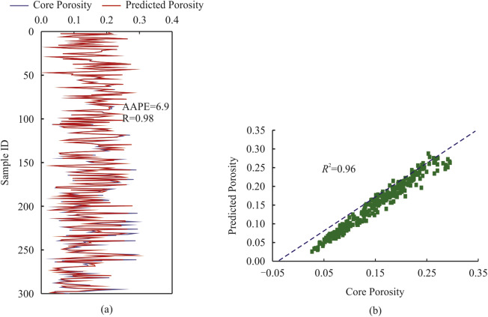

Figure 2. Core vs. Predicted Porosity Analysis.

**Description:** This figure consists of two subgraphs (a and b) that analyze the relationship between core porosity and predicted porosity.

Subgraph (a): Vertical Line Graph: Displays the porosity values for multiple samples, represented by Sample ID on the vertical axis.

Subgraph (b): Scatter Plot: Shows the relationship between core porosity and predicted porosity.

A graph of different colored lines



Figure 3. Porosity Comparison Histogram.

**Description:** This histogram compares the porosity values derived from two different methods: 3D Model porosity (upscaled) and Well logs porosity. The horizontal axis represents the range of porosity values, while the vertical axis shows the percentage of occurrences for each porosity value.

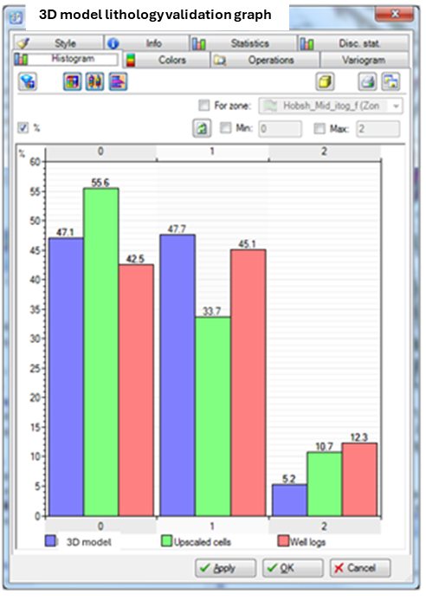

Figure 4. 3D Model Lithology Validation Graph.

**Description:** This graph compares the lithology validation results from three different sources: 3D Model, Upscaled Cells, and Well Logs. The horizontal axis represents different lithological categories, labeled from 0 to 2. The vertical axis indicates the percentage of occurrences for each category.

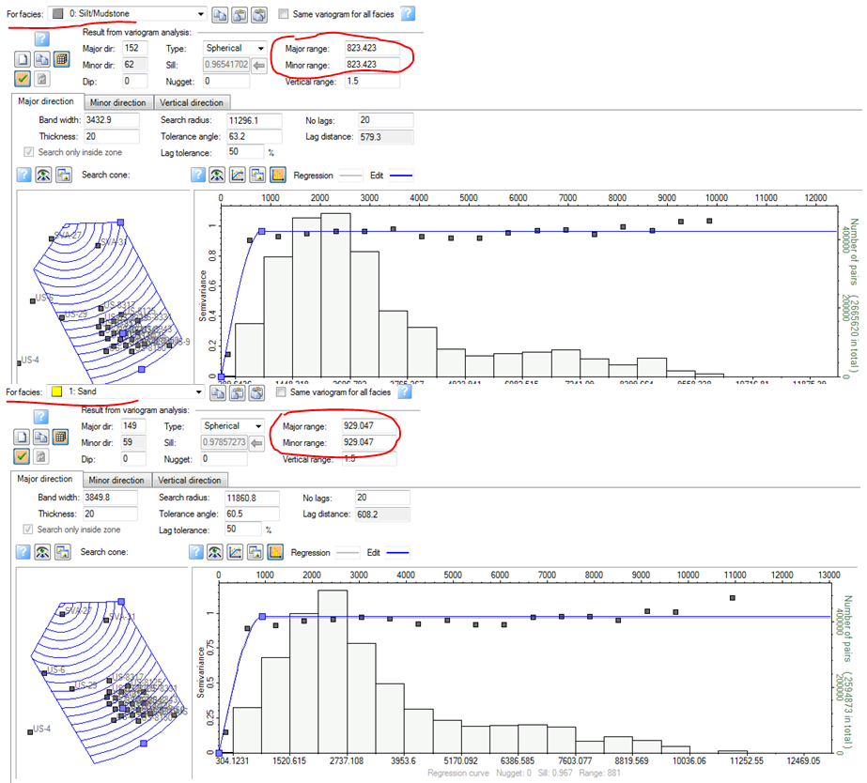

Figure 5. Variogram Analysis for different facies.

**Description:** This figure illustrates a variogram analysis for the Sand facies in a geological study, providing insights into the spatial correlation of the data. The parameters include a Major Range and Minor Range, both indicating the extent of spatial influence in the analysis. The Vertical Range is shown, reflecting depth-related variations in the spatial structure.

Permeability Cut-Off Estimation showing two (2) subgraphs.



**Figure 6. Permeability Cut-off Estimation.**

**Description:** This figure presents two subgraphs (a and b) that analyze the cutoff estimation for permeability based on different factors: pore-throat radius and effective porosity, providing valuable insights for geological studies and reservoir evaluations.